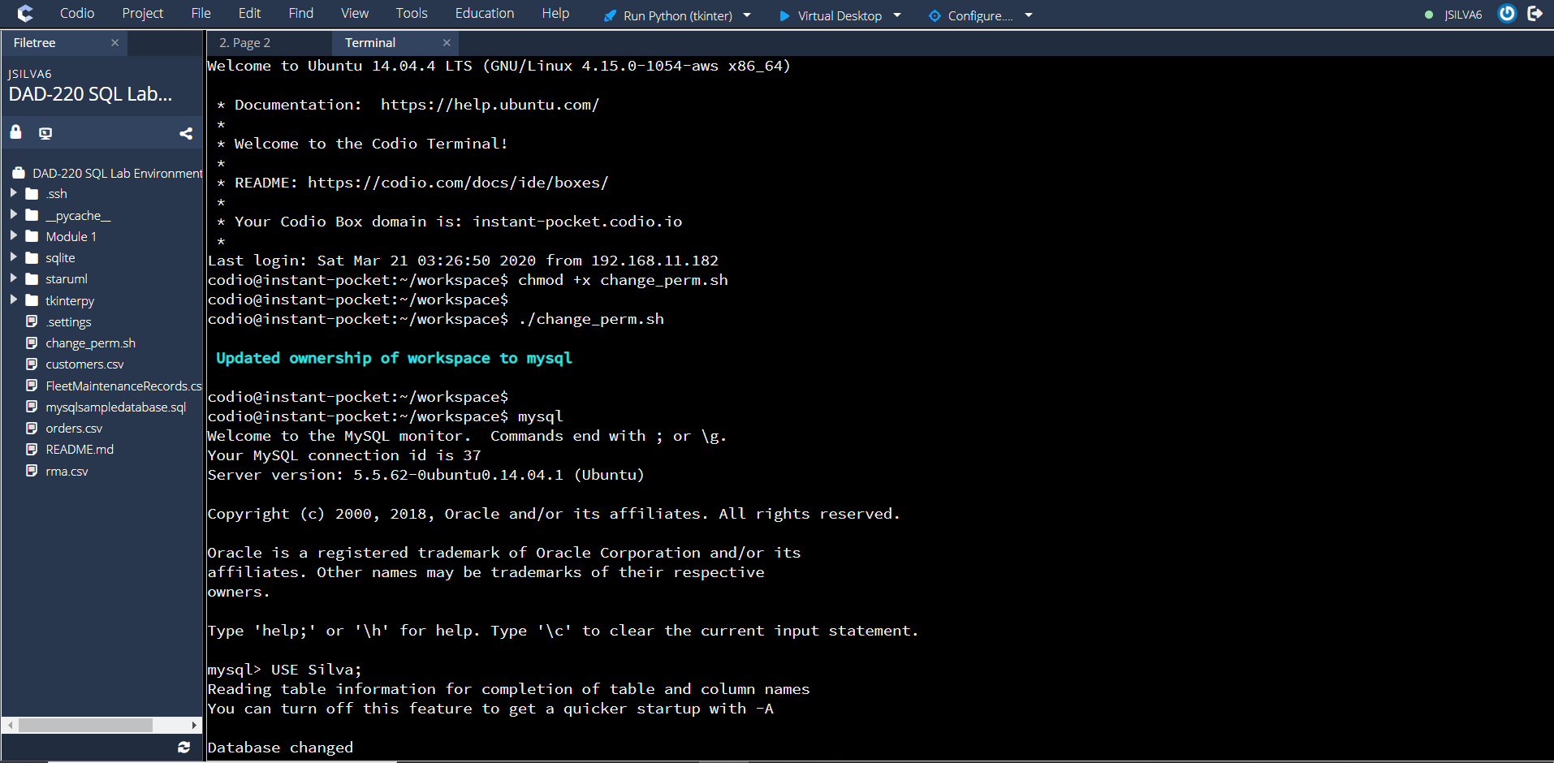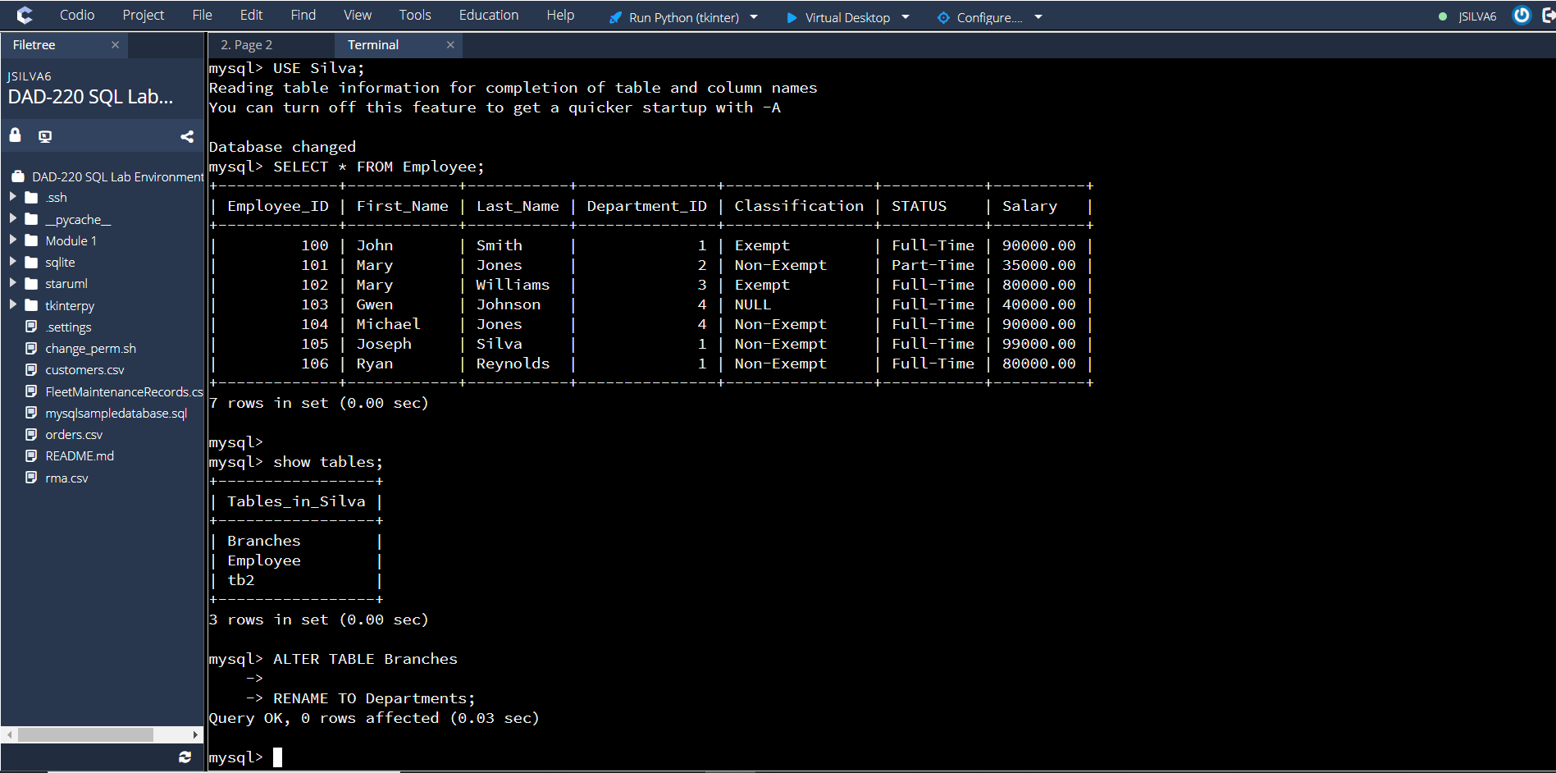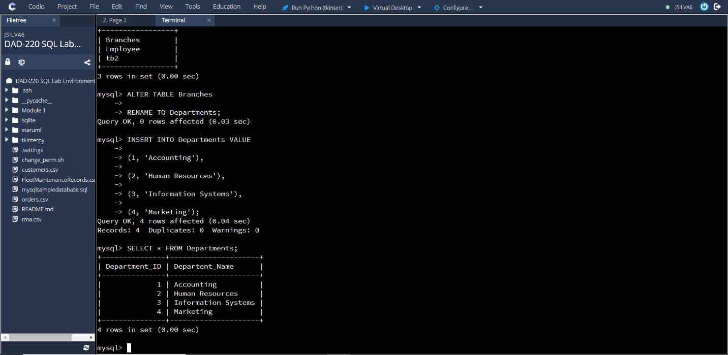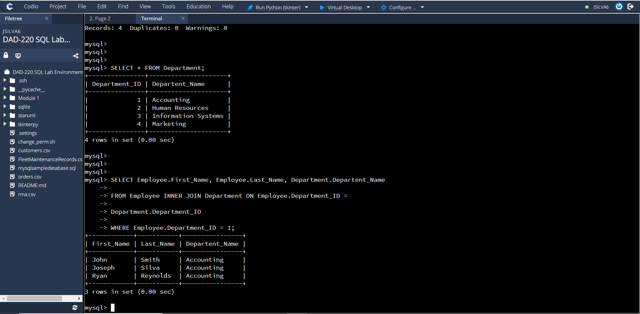

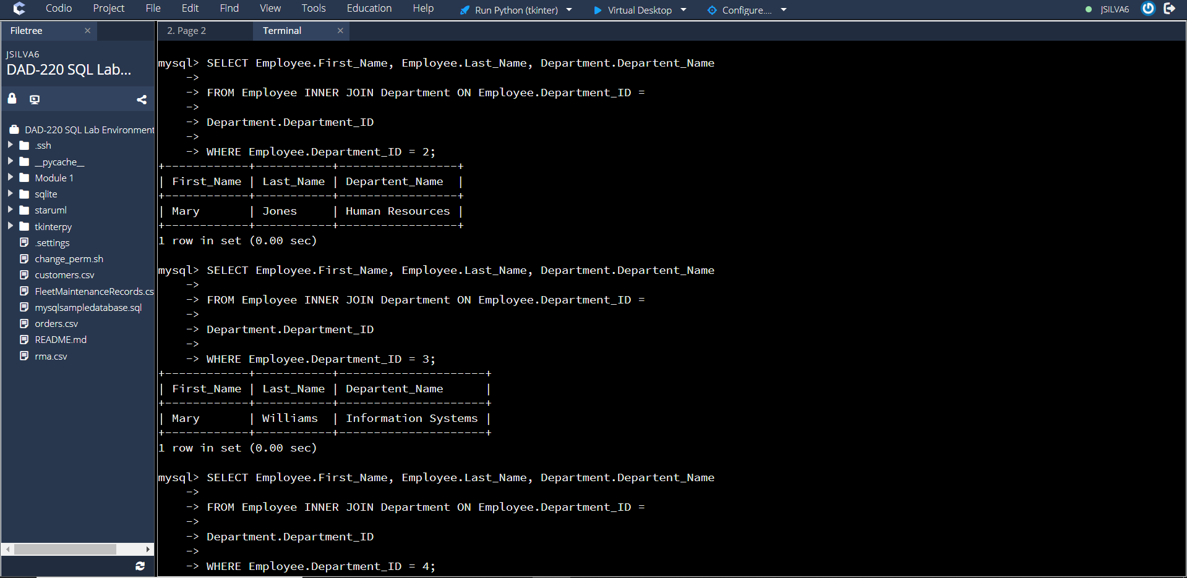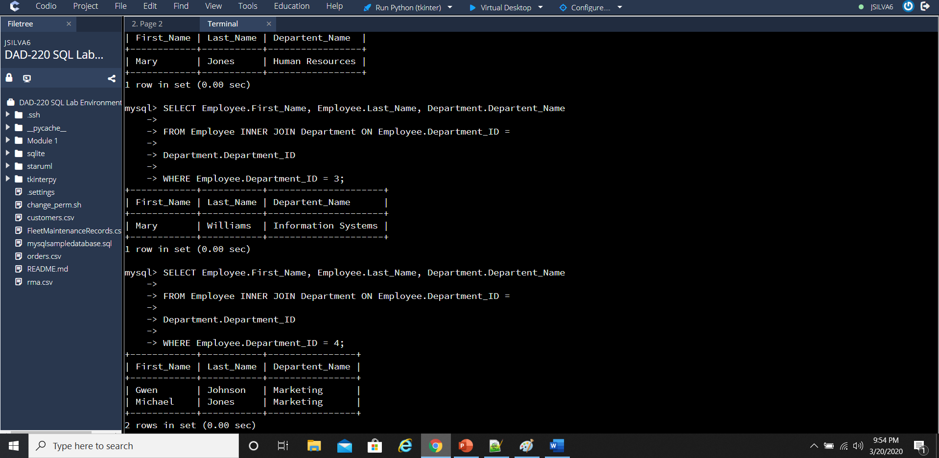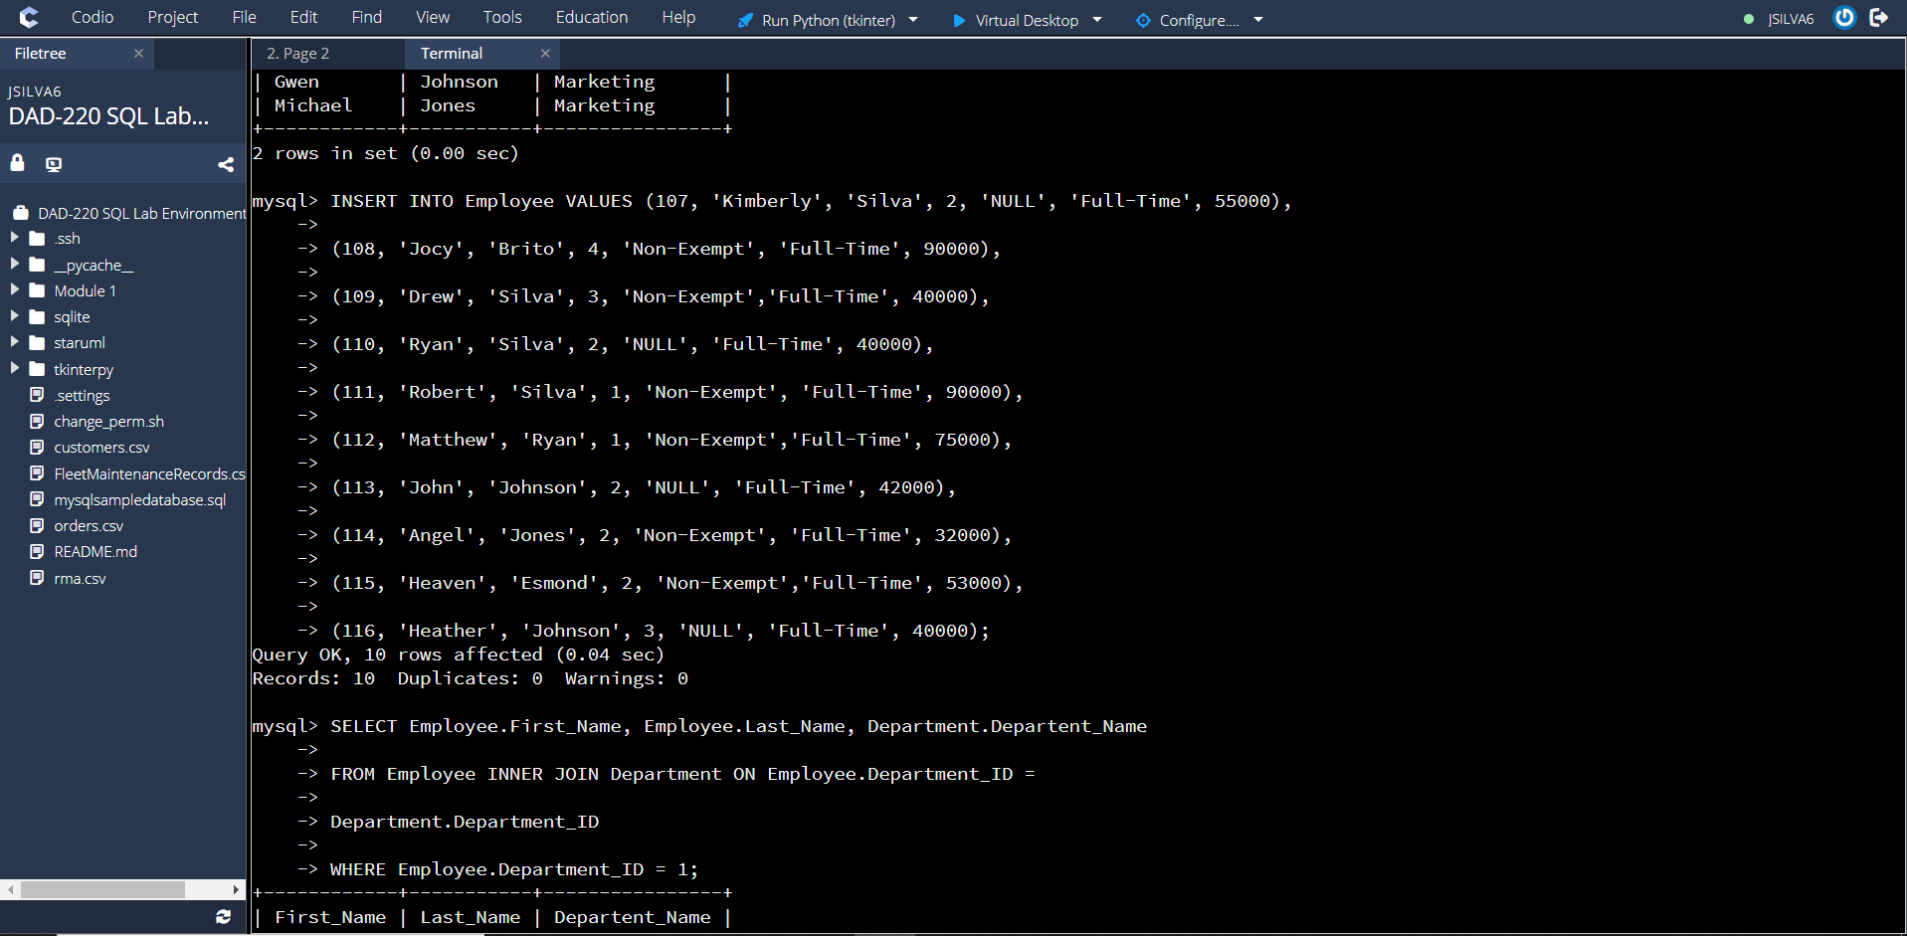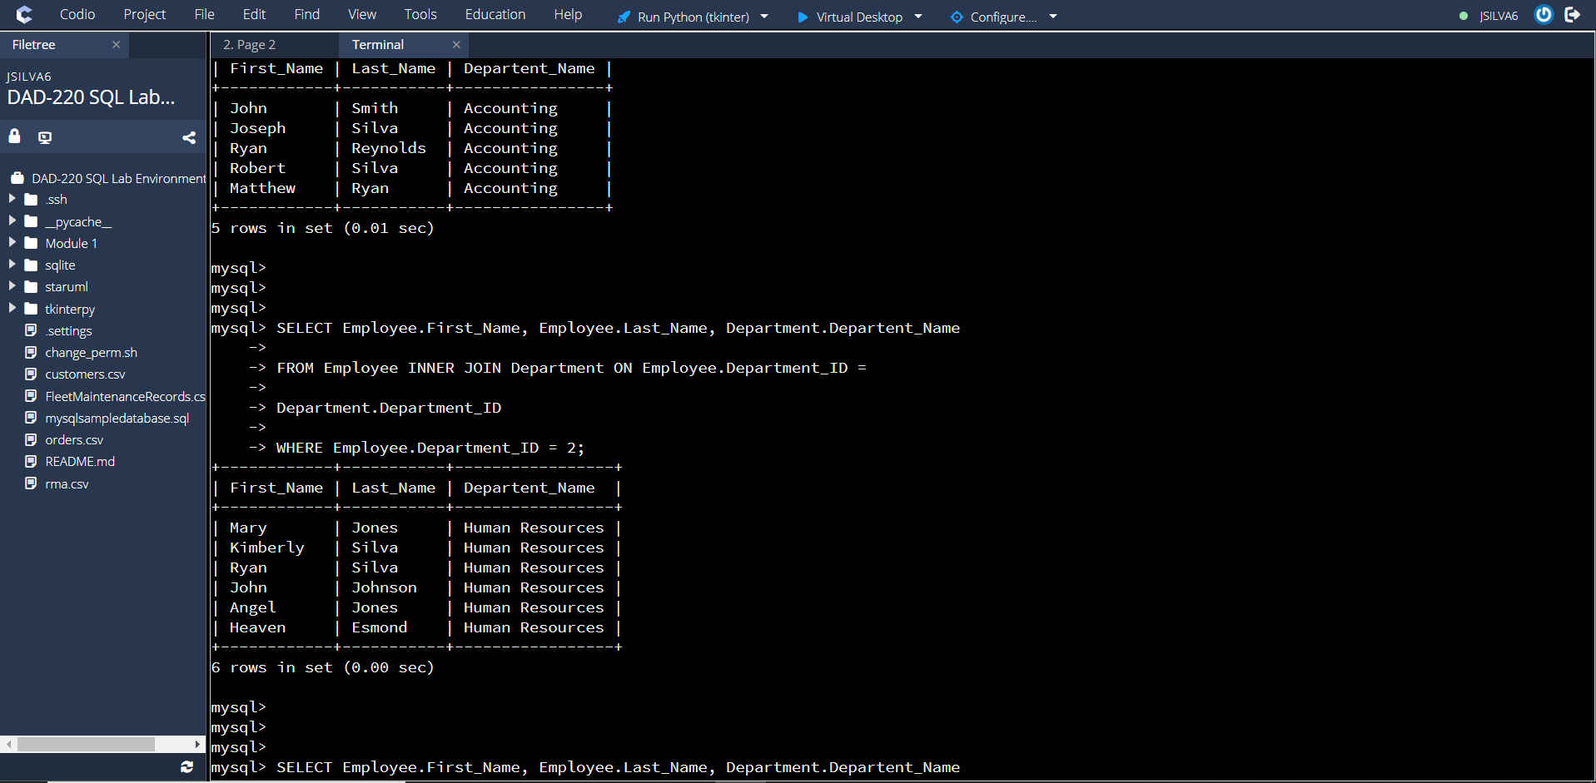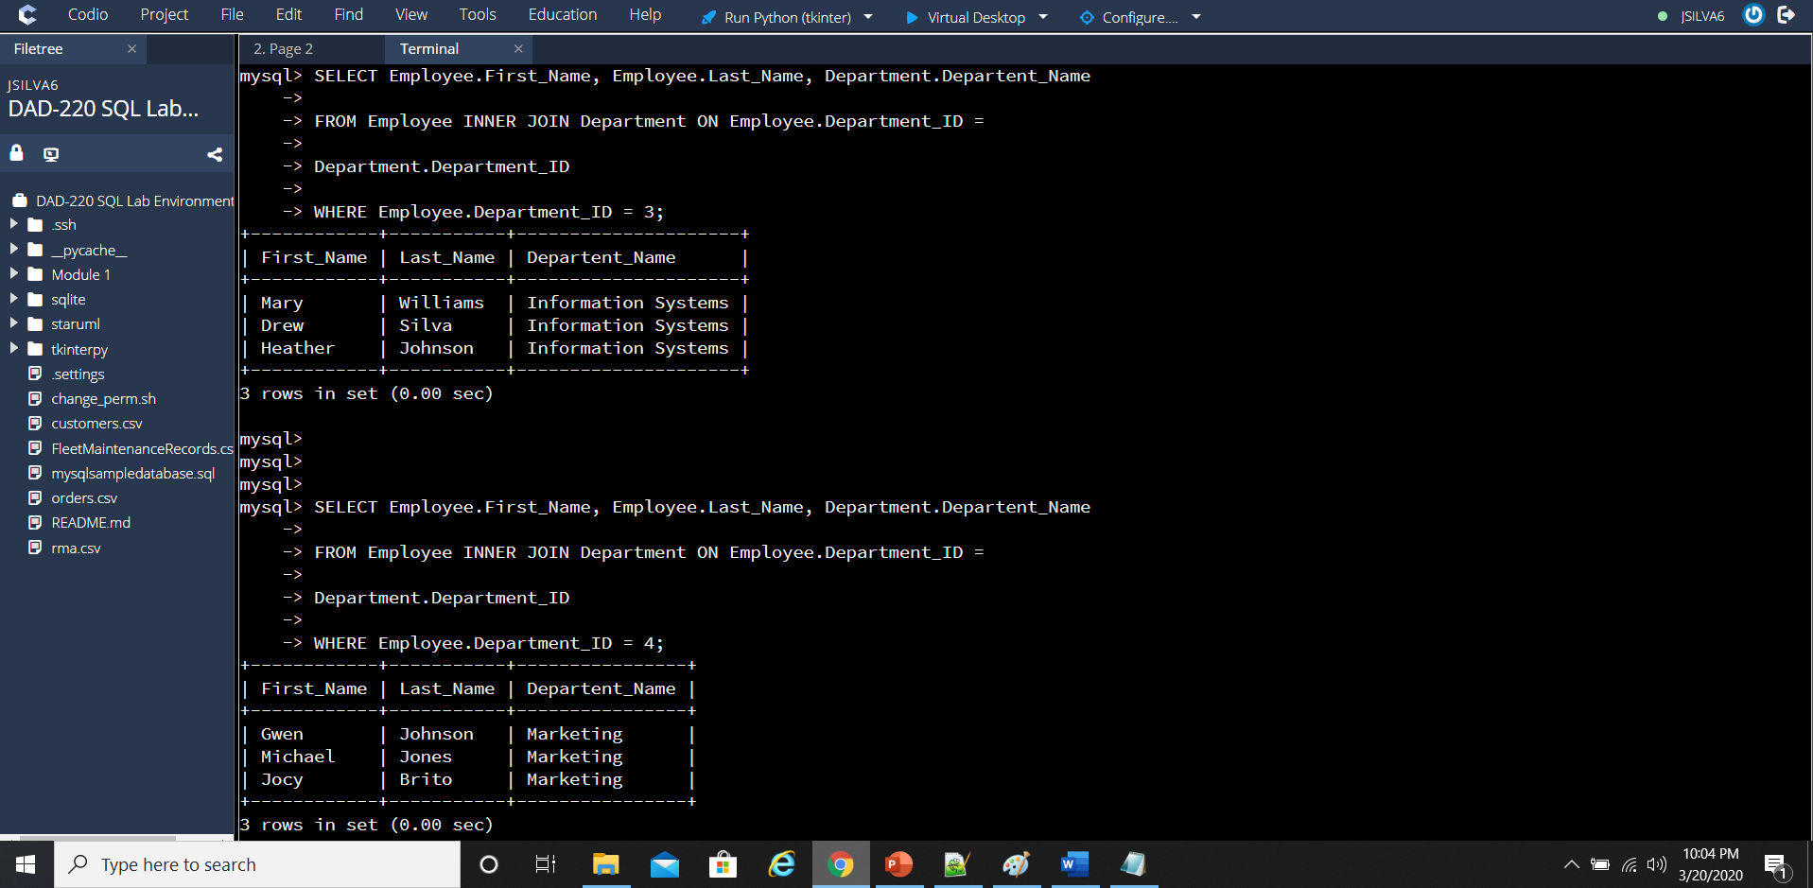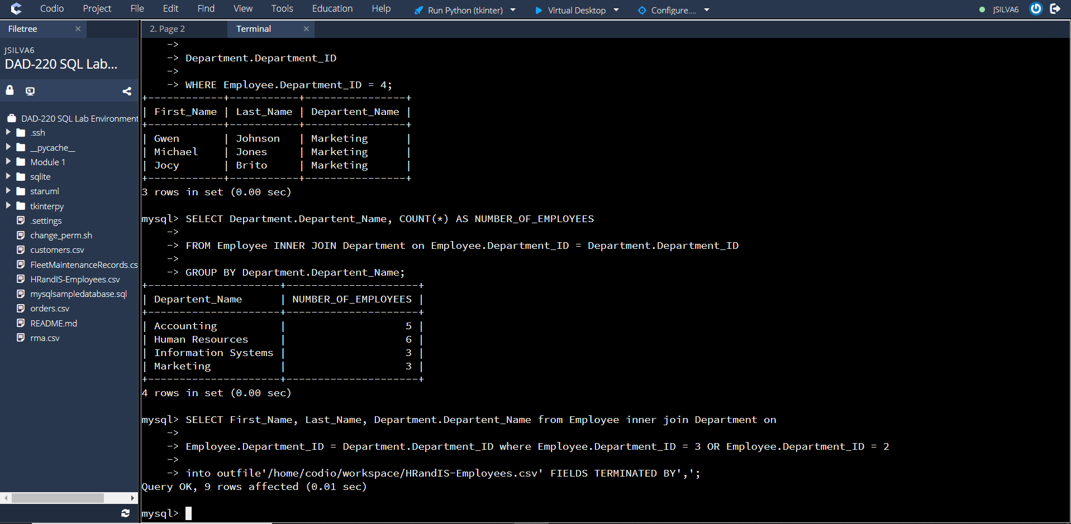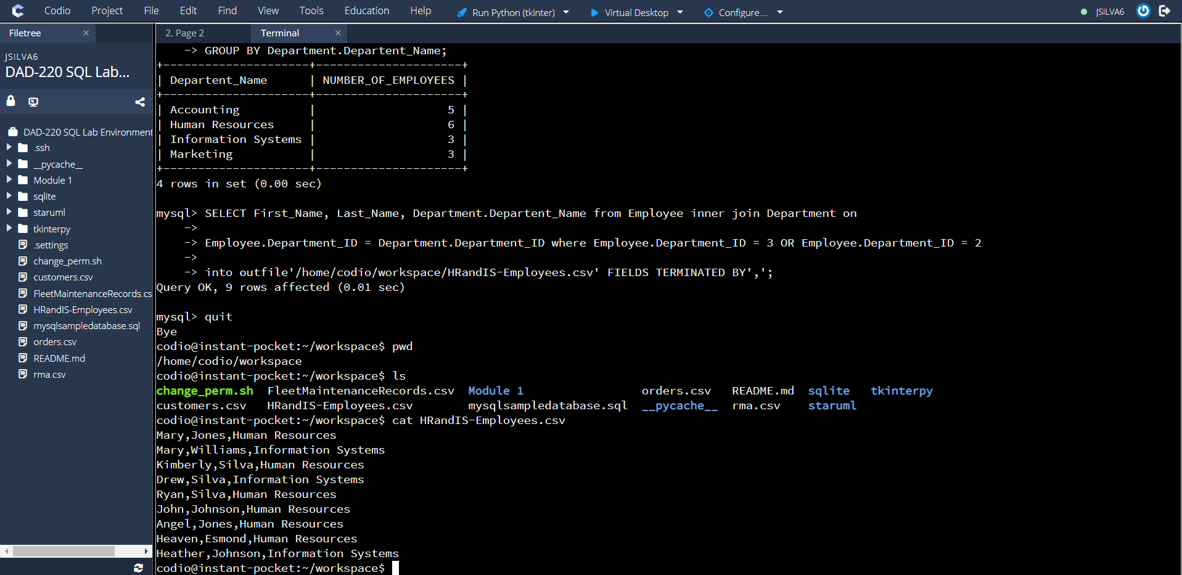

#1: I used the Inner JOIN command to combine the matched rows together with the Employee table and the Department table.

#2: I used the command ALTER TABLE Branches RENAME Departments to change the table name but keep the information inside of the table.

#3: The amount of records on the CVS file were 9. 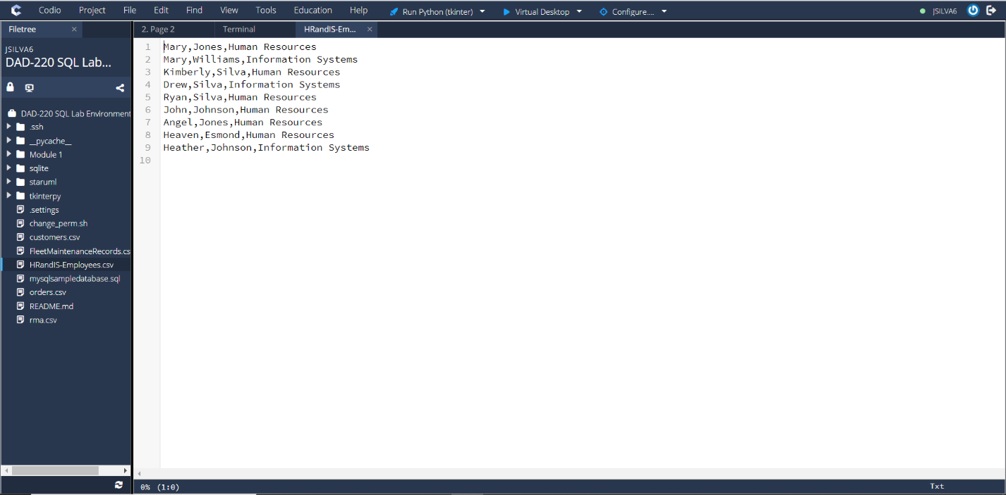

#4: The information transferred over was the first name, last name, and Department name. The information was collected from the Employees and Departments tables that were INNER JOIN. Any employee that had a Department ID = 2 or 3 had their first name, last name, and Department name transferred to the file named /home/codio/workspace/HRandIS-Employees.csv.